Prayer Box

Based on the beautiful Lord’s Prayer found in Matthew 6:5-15 and Jesus’ instruction about prayer, this sermon series covers 12 unique and essential instructions on prayer. Each week you are invited to a deeper prayer life and conversation with our loving God by writing a daily prayer and placing it in your prayer box.

Please feel free to use this digital prayer box, to keep track of your daily prayers over the next 12 weeks.

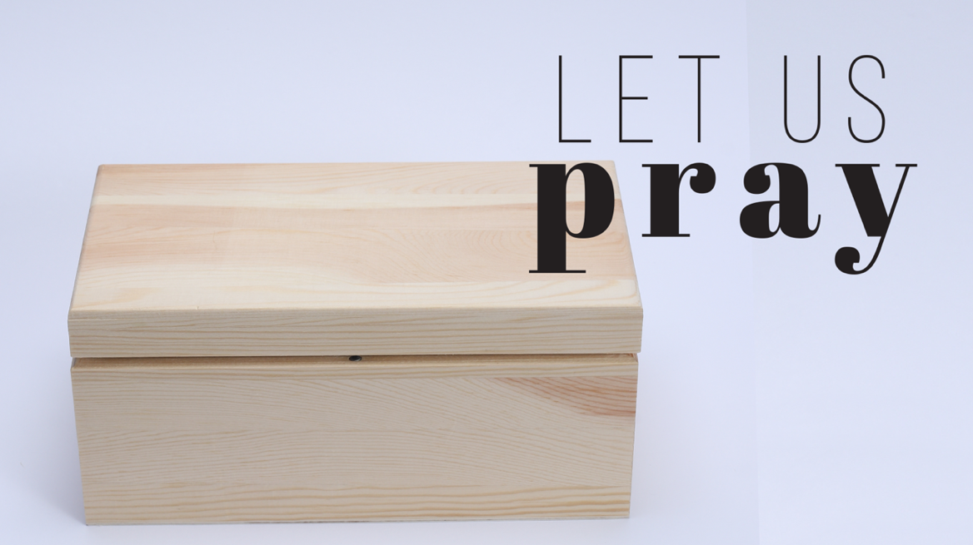

Instructions: Save this file on your desktop and open each day, scroll to the current week and day and type in your prayer. Don’t forget to click “Save” each day after recording your prayer.

# Jesus, Teach us to Pray

September 10th, 2023

Week 1 – Matthew 6:5-8

*“And when you pray, do not be like the hypocrites, for they love to pray standing in the synagogues and on the street corners to be seen by others…”*

Sunday

*Dear Jesus,*

Type your daily prayer here

Monday

*Dear Jesus,*

Type your daily prayer here

Tuesday

*Dear Jesus,*

Type your daily prayer here

Wednesday

*Dear Jesus,*

Type your daily prayer here

Thursday

*Dear Jesus,*

Type your daily prayer here

Friday

*Dear Jesus,*

Type your daily prayer here

Saturday

*Dear Jesus,*

Type your daily prayer here

# Our Father in heaven, hallowed be your name.

September 17th, 2023

Week 2 – Luke 1:46-55

*“My soul glorifies the Lord and my spirit rejoices in God my savior…”*

Sunday

*Dear Jesus,*

Type your daily prayer here

Monday

*Dear Jesus,*

Type your daily prayer here

Tuesday

*Dear Jesus,*

Type your daily prayer here

Wednesday

*Dear Jesus,*

Type your daily prayer here

Thursday

*Dear Jesus,*

Type your daily prayer here

Friday

*Dear Jesus,*

Type your daily prayer here

Saturday

*Dear Jesus,*

Type your daily prayer here

# Your Kingdom Come

September 24th, 2023

Week 3 – Matthew 5:1-12

*“Blessed are…”*

Sunday

*Dear Jesus,*

Type your daily prayer here

Monday

*Dear Jesus,*

Type your daily prayer here

Tuesday

*Dear Jesus,*

Type your daily prayer here

Wednesday

*Dear Jesus,*

Type your daily prayer here

Thursday

*Dear Jesus,*

Type your daily prayer here

Friday

*Dear Jesus,*

Type your daily prayer here

Saturday

*Dear Jesus,*

Type your daily prayer here

# Your Will be Done

October 1st, 2023

Week 4 – John 15:1-8

*“I am the vine; you are the branches. If you remain in me and I in you, you will bear much fruit; apart from me you can do nothing.”*

Sunday

*Dear Jesus,*

Type your daily prayer here

Monday

*Dear Jesus,*

Type your daily prayer here

Tuesday

*Dear Jesus,*

Type your daily prayer here

Wednesday

*Dear Jesus,*

Type your daily prayer here

Thursday

*Dear Jesus,*

Type your daily prayer here

Friday

*Dear Jesus,*

Type your daily prayer here

Saturday

*Dear Jesus,*

Type your daily prayer here

# On Earth as it is in Heaven

October 8th, 2023

Week 5 – John 1:1-18

*“The Word became flesh and made his dwelling among us. We have seen his glory, the glory of the one and only Son, who came from the Father, full of grace and truth.”*

Sunday

*Dear Jesus,*

Type your daily prayer here

Monday

*Dear Jesus,*

Type your daily prayer here

Tuesday

*Dear Jesus,*

Type your daily prayer here

Wednesday

*Dear Jesus,*

Type your daily prayer here

Thursday

*Dear Jesus,*

Type your daily prayer here

Friday

*Dear Jesus,*

Type your daily prayer here

Saturday

*Dear Jesus,*

Type your daily prayer here

# Give us Today our Daily Bread

October 15th, 2023

Week 6 – Luke 24:13-35

*“On the Road to Emmaus”*

Sunday

*Dear Jesus,*

Type your daily prayer here

Monday

*Dear Jesus,*

Type your daily prayer here

Tuesday

*Dear Jesus,*

Type your daily prayer here

Wednesday

*Dear Jesus,*

Type your daily prayer here

Thursday

*Dear Jesus,*

Type your daily prayer here

Friday

*Dear Jesus,*

Type your daily prayer here

Saturday

*Dear Jesus,*

Type your daily prayer here

# Forgive Us Our Debts

October 22nd, 2023

Week 7 – Isaiah 43:14-25 & 1 John 1:7-9

*“I, even I, am he who blots out your transgressions, for my own sake, and remembers your sins no more”*

Sunday

*Dear Jesus,*

Type your daily prayer here

Monday

*Dear Jesus,*

Type your daily prayer here

Tuesday

*Dear Jesus,*

Type your daily prayer here

Wednesday

*Dear Jesus,*

Type your daily prayer here

Thursday

*Dear Jesus,*

Type your daily prayer here

Friday

*Dear Jesus,*

Type your daily prayer here

Saturday

*Dear Jesus,*

Type your daily prayer here

# As We also Have Forgiven our Debtors

October 29th, 2023

Week 8 – 2 Corinthians 9:6-7

*“Remember this: Whoever sows sparingly will also reap sparingly, and whoever sows generously will also reap generously”*

Sunday

*Dear Jesus,*

Type your daily prayer here

Monday

*Dear Jesus,*

Type your daily prayer here

Tuesday

*Dear Jesus,*

Type your daily prayer here

Wednesday

*Dear Jesus,*

Type your daily prayer here

Thursday

*Dear Jesus,*

Type your daily prayer here

Friday

*Dear Jesus,*

Type your daily prayer here

Saturday

*Dear Jesus,*

Type your daily prayer here

# Lead Us Not into Temptation

November 5th, 2023

Week 9 – John 3:1-15

*“Very truly I tell you, no one can enter the kingdom of God unless they are born of water and the Spirit…”*

Sunday

*Dear Jesus,*

Type your daily prayer here

Monday

*Dear Jesus,*

Type your daily prayer here

Tuesday

*Dear Jesus,*

Type your daily prayer here

Wednesday

*Dear Jesus,*

Type your daily prayer here

Thursday

*Dear Jesus,*

Type your daily prayer here

Friday

*Dear Jesus,*

Type your daily prayer here

Saturday

*Dear Jesus,*

Type your daily prayer here

# Deliver Us From the Evil One

November 12th, 2023

Week 10 – Psalm 121 & 2 Thessalonians 3:1-5

*“My help comes from the Lord, the Maker of heaven and earth.”*

Sunday

*Dear Jesus,*

Type your daily prayer here

Monday

*Dear Jesus,*

Type your daily prayer here

Tuesday

*Dear Jesus,*

Type your daily prayer here

Wednesday

*Dear Jesus,*

Type your daily prayer here

Thursday

*Dear Jesus,*

Type your daily prayer here

Friday

*Dear Jesus,*

Type your daily prayer here

Saturday

*Dear Jesus,*

Type your daily prayer here

# Living Prayer in the Church

November 19th, 2023

Week 11 – John 13:34-35

*“A new command I give you: Love one another. As I have loved you, so you must love one another.”*

Sunday

*Dear Jesus,*

Type your daily prayer here

Monday

*Dear Jesus,*

Type your daily prayer here

Tuesday

*Dear Jesus,*

Type your daily prayer here

Wednesday

*Dear Jesus,*

Type your daily prayer here

Thursday

*Dear Jesus,*

Type your daily prayer here

Friday

*Dear Jesus,*

Type your daily prayer here

Saturday

*Dear Jesus,*

Type your daily prayer here

# Prayer for the Church

November 26th, 2023

Week 12 – Ephesians 3:14-21

*“For this reason I kneel before the Father, from whom every family in heaven and on earth derives its name.”*

Sunday

*Dear Jesus,*

Type your daily prayer here

Monday

*Dear Jesus,*

Type your daily prayer here

Tuesday

*Dear Jesus,*

Type your daily prayer here

Wednesday

*Dear Jesus,*

Type your daily prayer here

Thursday

*Dear Jesus,*

Type your daily prayer here

Friday

*Dear Jesus,*

Type your daily prayer here

Saturday

*Dear Jesus,*

Type your daily prayer here